Team: IMPULSE
Elastic version
Our company Yokogawa is a global solution and service company contributing to the society with cleaner, greener, safer and innovative products. We are one of the world leaders in industrial automation and control, test and measurement, information systems and industrial services. Our comprehensive solutions range from sensors (such as pressure transmitters, flow meters and analysers) to control systems, software that improves productivity and services that optimize plant lifecycle management. These solutions currently play a vital supporting role to our customers in the oil & gas, chemical, electric power, iron and steel, pharmaceuticals, food and semiconductor industries. We focus on high quality, innovation and safety through our products.
With pioneer spirit, integrity and commitment towards the cause of serving the society, we aim to be the market leaders by 2015, which also marks our centenary year. I, as part of Yokogawa family take pride in building this dream together.
Post-it note
Our company is a global service and solutions provider in measurement, control and information. We continuously work towards contributing to the society by building products of high quality in the domain of Industrial Automation. With pioneer spirit, integrity and commitment towards the cause we aim to be market leaders by 2015, which also marks our centenary year and I as part of Yokogawa family take pride in building this dream together.
Pros:
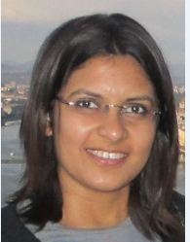
Ronita Krishna
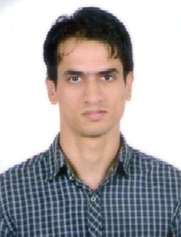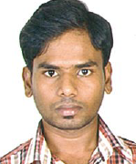
Pankaj Santhosh
- Had sense of belonging
- Beginning and conclusion were good.
- Flow was good
Cons:
- Abridged version was not really abridged
- Content was too long.

